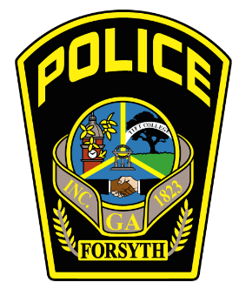
UNSOLVED HOMICIDE – MEDIA RELEASE

Forsyth Police Department - Woodrow W. Blue, Jr. – Chief of Police
P.O. Box 1447 or 200 South Kimball Street.
Tel: (478) 993-1005
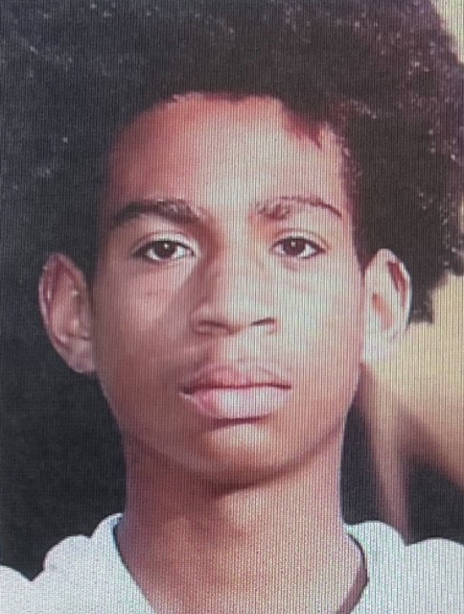
The Forsyth Police Department needs the public help with information related to a shooting that took place June 4, 2023, in the Milledge Circle area of Forsyth, Georgia. Investigators were advised that a music video was being made the night of a graduation party where gunshots were reported, leaving three wounded. There was a report of a red & yellow vehicle leaving the scene at a high rate of speed that might have been involved with the shooting. The person shown in the above photo, JD Walton, did not survive.
If you have any details, no matter how small, do your part to help give the family closure and Make the Call.

Please call 877-68CRIME or 478-742.2330 or www.crimestop.us and select “Submit a Tip.”

